3-year Development Plan
Over 3 years we will fulfil our over-arching goal. All of our goals are driven by our vision, values, curriculum drivers and school context.
OUR VISION
'Working together to make a difference'; To instill a Love of Learning within a Respectful and Caring Community.
OUR ETHOS
We provide a happy, caring and stimulating learning environment, responsive to the needs and learning styles of every child. The staff team value each child as an individual, recognising their own unique talents and abilities.
We have the highest educational standards and expectations for all the children in our care. We strive to ensure that every child achieves their personal best. Pentland is a very active and vibrant school, offering a broad, balanced and creative curriculum. Activities are carefully planned, with the aim of helping children to receive as wide a range of first-hand experiences as possible to stimulate their interest and love of learning; one which we hope will stay with them throughout their life.
At Pentland a high emphasis is placed on helping children to develop the skills that will carry them through their educational journey and later into the world of work. Our aim is to help children to grow into confident, talented and articulate young people, who have a good command of literacy and numeracy skills and are ready to contribute successfully to an ever-changing and increasingly technological world.
Pentland is a respectful and inclusive community. High expectations are in place to guide and develop positive behaviours. Children are helped to recognise their rights and responsibilities; to develop respect for themselves, for others in school and beyond. We celebrate diversity and teach children to recognise and respect people’s differences as well as their similarities.
The staff within school, work hard to create a welcoming ethos, one which is built on trust and mutual respect. It is our whole-hearted belief that it is essential to work in full partnership with parents, carers and the wider community to ensure that each individual child feels part of school life and gains the most from their time here.

OUR CURRICULUM DRIVERS
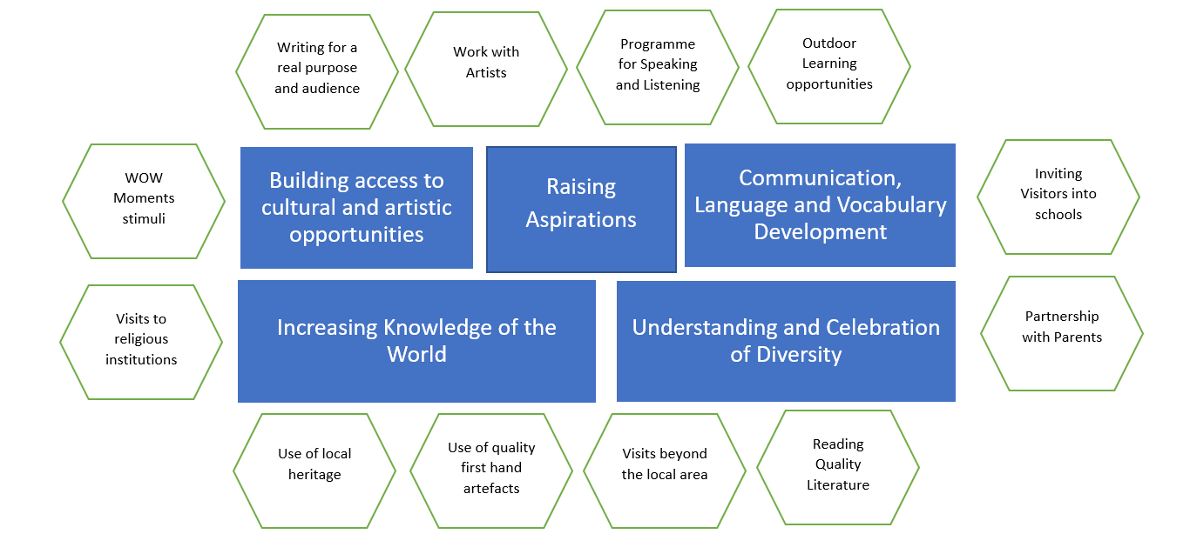

Quality of Education
Goal: Staff have strong and secure subject knowledge in all areas, leading to strong progress for all, but particularly for boys, disadvantaged learners and those with SEND.

2022-23  (RAG Rating Feb 2023) |  | 2023-24 | 2024-25
- CPD for middle leaders regarding subject leadership/ deep dives  - CPD for priority areas: Phonics, Reading, Writing, Maths, PE, History/Geography  - CPD around expectations and meeting the needs of SEND  - CPD around needs of disadvantaged learners  - Undertake deep dives  - Embed Little Wandle SSP with 100% fidelity  - Review Little Wandle and encoding opportunities (opportunities for writing)  - Implement assessment schedule and approaches to assessment  - Termly pupil progress meetings  - Workshops for parents of boys (**workshops for all age groups) | - Review Accessibility Plan  - Pupil voice SEND and Disadvantaged pupils  - CPD for wider curriculum areas: RE, science, computing and music.  - Writing focus |  | - CPD for wider curriculum areas: design technology and art.
LGB Monitoring 2022-23

- Establish governor link roles and visits (English, PE and Safeguarding – Dec 2022; DK led training for Governors – Nov 2022)
- Subject leader presentations for the Governors (Action: Spring Term)
- Review the CPD plan (FF to review Spring Term; PB to be used to cover CPD/PDT)
- Attendance at workshops (Celebrated weekly; Parent Workshops have started for Y2, Y1, YR and Phonics)
- Sharing of external visit reports (Shared with Chair & Vice Chair)
- Learning Walks (Started November 2022; PE, Safeguarding, English, SEND)

Behaviour and Attitudes
Goal: High attendance and punctuality for all pupils. Behaviour policy is embedded and fully understood by all.
2022-23 | 2023-24 |  | 2024-25
- Regular liaison with the Attendance Officer (attendance office on the door each morning with a member of the SLT; Attendance meetings have begun on a rolling programme; very high % of absence due to prolific bugs/viruses)  - Apply rigorous systems to monitoring and attendance  - Office systems are robust and implemented effectively  - Reward punctuality and attendance  - Ensure the curriculum offer remains engaging to encourage punctuality  - Proactive communication with all parents regarding punctuality and attendance.  - Implement a Wake Up, Shake Up offer and encourage attendance at Breakfast Club  - Review curriculum provision to address potential gaps in learning caused by attendance  - Review and implement Behaviour Policy | - Review and evaluate Behaviour Policy and include Pupil Voice.  - Review and evaluate Attendance Policy incorporating parent voice. |  | - Fully embed the Behaviour Policy
LGB Monitoring 2022-23
- Pastoral data
- Policy reviews (behaviour and attitudes)
- Survey outcomes
Personal Development
Goal: All pupils recognise risk and how to stay safe online. Children will have an understanding of a range of careers, and further and higher education.

2022-23 | 2023-24 |  | 2024-25
- Re-Introduce Class Assemblies for parents  - Review Policy  - CPD for staff  - Review filtering (sampling of pupil use)  - Review Acceptable Use policies for pupils and staff  - Workshop for parents (online safety)  - Include Online Safety within assembly themes  - Review assembly material to include consent and protected characteristics. (Review throughout the year – sticky knowledge)  - Reinstate ELSA  - Assembly Plans further develop the School Values and fundamental British Values | - Establish careers week  - Review and evaluate the impact of the Online Safety Policy  - Year Two to plan and lead a parent assembly about online safety |  | - Embed careers week  - Review of Online Safety Policy
LGB Monitoring 2022-23
- Review policies
- Review impact of policies
- Presentation of Computing lead to Governors
- Attendance at Year 2 assembly
- Attendance at Careers Week [FF to plan]
Action Plan: Leadership and Management
Goal: There is strong leadership at all levels to fulfil vision and values. The Pentland curriculum is fully sequenced and carefully planned to fulfil school aims. Stakeholders fully support school improvement through holding Senior Leaders to account.

2022-23 | 2023-24 |  | 2024-25
- Recruitment of two substantive leadership roles  - Shared expectations of roles and responsibilities  - Subject leader CPD  - Implement monitoring and evaluation schedule  - Implement assessment schedule  - Review Cornerstones to meet the needs of Pentland pupils  - Deep Dives in specific curriculum areas (Phonics, Early Reading, Maths, History/ Geography, PE)  - Curriculum Surveys for all subjects  - Deep dive training for Governors  - ECT Induction and Mentoring  - CPD in Mastery Readiness (Maths Leaders)  - Vocabulary CPD for all staff | - Deep Dives and CPD: RE, science, and music.  - Curriculum Surveys for all subjects  - Parent curriculum surveys  - NPQ Qualifications for Middle Leaders and/or Subject Leaders  - ECT Induction and Mentoring  - Explore a Summer School offer  - Explore wrap around school care (breakfast club and after school club) |  | - Deep Dives and CPD: design technology and art.
LGB Monitoring 2022-23
- Subject leader presentations
- Learning Walks
- Deep dive reports
- Subject-specific data and outcomes
- Pupil voice interviews

Action Plan: EYFS
Goal: An Early Years curriculum for Pre-School, Nursery and Reception is embedded, and fully supports the curriculum drivers. There will be improved outcomes in language-based learning.

2022-23 |  | 2023-24 | 2024-25
- Review of the curriculum to include overarching topics for Preschool, Nursery and Reception  - Overarching text/ literacy spine for EYFS  - Environment effectively supports learning  - Key vocabulary is progressive and on display  - CPD for EYFS Team  - Ensuring all observations document new learning  - Agree and implement next steps readiness for Nursery and Reception  - Plan high quality opportunities for writing within the continuous provision  - Replicate mark making opportunities within the CP to reflect the phonics stage  - Regular monitoring of quality of provision and timely support  - Shared expectation of Standard English from all adults.  - Set up moderation with other schools in the local area  - Implement updated assessment and observation system  - Implement and review a continuous provision staffing plan  - Support the development of a high-quality 2-year-old provision  - Provide opportunities for children to develop fine motor skills through the continuous provision  - Implement NELI programme for targeted pupils |  | - Review the LTP and Curriculum Mapping  - Writing CPD  - Review outdoor provision  - Review the visits and visitors to support and enhance the curriculum, particularly in lower attaining areas of the curriculum (e.g., Understanding the World) | - Explore a Summer School offer
LGB Monitoring 2022-23
- Learning Walks
- Deep dive reports
- Data and outcomes
- Pupil voice interviews

